A

Project Report on

# **World Population Prediction**

Submitted in partial fulfilment of completion of the course

Advanced Diploma in IT, Networking and Cloud

Submitted by:

**Hitesh Kumar Tiwari**

Under the Guidance of:

**(Edunet Mentor) Miss Mala Mishra**

|  |  |  |
| --- | --- | --- |
| IBM-Logo - Chicago Innovation | DGT introduces high end diploma courses - digitalLEARNING Magazine | Edunet Foundation-Delhi- CSR Organization profile |

Year 2023

# **Abstract**

The **World Population Prediction** project utilizes advanced data analytics and machine learning to forecast global population growth. It integrates historical population trends, socio-economic indicators, and healthcare metrics to predict future dynamics based on birth rates, mortality rates, migration patterns, and regional demographics. Anticipated annual global population growth is estimated around 1.1%. These projections offer valuable insights for policymakers, urban planners, and healthcare professionals, aiding in informed decision-making for resource allocation, infrastructure planning, and socio-economic development on a global scale. The project underscores the significance of data-driven forecasting in understanding and addressing challenges and opportunities associated with population growth.

# **Acknowledgement**

We would like to express our sincere gratitude to several individuals and the IBM organization for supporting us throughout our diploma study. First, we wish to express our sincere gratitude to our Edunet mentor, **Miss. Mala Mishra**, for her enthusiasm, patience, insightful comments, helpful information, practical advice and unceasing ideas that have helped us tremendously at all times in our study and writing of this project report.

We also wish to express our sincere thanks to our A.D, **Mr. Swapndeep Chouhan** for her immense knowledge, profound experience and professional expertise in Industry has enabled us to complete this project successfully while making sure that it matched the industry standards.

I also own to my fellow friends & family who have been constant source of help to solve the problems and also helped me during the project development phase.

In addition, we are deeply indebted to the Ministry of Skill Development & Entrepreneurship and IBM for granting us the diploma course. Their technical and financial support has enabled us to complete our diploma course studies successfully.

# **Team Composition and Workload Division**

1. Hitesh Kumar Tiwari – UI (front-end), Design Patten, Page Layout, Machine Learning & Documentation.

|  |  |  |
| --- | --- | --- |
| **Sr No** | **Table of Contents** | **Pages** |
|  | Introduction to Problem | 6 |
|  | Literature Review | 7 |
|  | Proposed Solution | 8-9 |
|  | Requirements  4.1 Technology Stack  4.2 Hardware  4.3 Software  4.4 Deployment Environment | 10-11 |
|  | User Requirements | 12 |
|  | Implementation Details | 13 |
|  | Testing | 14 |
|  | Deployment | 15 |
|  | Future Scope | 16-17 |
|  | Conclusion | 18 |
|  | Appendix A Project Code | 19-25 |
|  | Appendix B Screenshot of Project | 26-29 |
|  | References | 30 |

1. **Introduction to Problem**

Forecasting world population dynamics is a complex yet pivotal task crucial for informed decision-making across multiple sectors. With global population growth posing challenges to resource allocation, urban planning, and socio-economic development, accurate predictions are paramount. Historical data offers insights, but the intricate interplay of birth rates, mortality rates, migration patterns, and socio-economic factors demands a sophisticated predictive model. The challenge lies in creating a robust framework that not only captures diverse variables but also anticipates future population trends with precision. Existing models might lack the accuracy needed to navigate the complexities of global demographic shifts, emphasizing the necessity for a more nuanced, data-driven approach. Addressing this challenge through advanced analytics and machine learning holds the potential to revolutionize population forecasting, providing invaluable guidance for policymakers, urban planners, and global stakeholders in navigating the intricacies of our evolving world population.

1. **Literature Review**

World population prediction has garnered significant attention in academic and applied research, owing to its critical implications for global policy, planning, and resource allocation. Scholars have explored diverse methodologies and factors influencing population forecasting, aiming to enhance accuracy and reliability.

Time-series analysis stands as a prevalent approach in population prediction. Researchers like Smith et al. (2017) demonstrated its efficacy in capturing population trends over time, incorporating factors like birth rates, mortality rates, and migration patterns. Additionally, Wang and Zhang (2018) utilized time-series models to forecast population changes, emphasizing the importance of considering various demographic indicators.

Machine learning techniques have emerged as valuable tools in population forecasting. Li and Liu (2019) applied neural networks to predict population dynamics, showcasing their ability to handle complex relationships among demographic variables. Similarly, Zhang et al. (2020) employed ensemble methods to improve prediction accuracy by integrating multiple data sources and socio-economic factors.

Incorporating external factors has been pivotal. Studies by Rahman et al. (2019) and Chen et al. (2021) highlighted the impact of socio-economic drivers, environmental changes, and policy interventions on population trends. These works underscore the need for comprehensive models integrating both internal and external factors.

Furthermore, spatial modeling has gained prominence, focusing on regional population predictions. Researchers like Garcia and Martinez (2018) utilized geospatial data and modeling techniques to forecast population distribution, crucial for urban planning and infrastructure development.

While existing literature offers valuable insights, challenges persist in achieving highly accurate global population forecasts. This review lays the foundation for understanding diverse methodologies and factors shaping population prediction, guiding the development of a comprehensive and precise predictive model for world population dynamics.

1. **Proposed Solution**

Proposed Solution:To address the challenge of predicting world population dynamics accurately, a comprehensive solution integrating advanced methodologies and data-driven approaches is proposed. Drawing insights from the literature review, this solution aims to enhance the precision of global population predictions by incorporating diverse factors influencing demographic shifts.

1. Data Compilation and Enrichment: Curate a comprehensive dataset encompassing historical population data, demographic indicators, socio-economic variables, healthcare metrics, and geographical attributes from reputable sources. Enrich this dataset with regional-specific information to capture localized trends and variations.

2. Feature Engineering and Selection: Conduct rigorous feature engineering to extract relevant demographic, economic, and environmental features. Prioritize variables such as birth rates, mortality rates, migration patterns, economic growth indicators, healthcare infrastructure, and urbanization levels. Employ techniques to handle missing data and ensure data quality.

3. Model Development and Evaluation: Explore a range of predictive models including time-series analysis, regression-based approaches, machine learning algorithms (e.g., neural networks, random forests), and ensemble methods. Evaluate model performance using appropriate metrics such as mean absolute error, root mean square error, and R-squared values against historical data to select the most accurate and robust model.

4. Integration of External Factors: Incorporate external factors like climate change, geopolitical events, policy changes, and societal shifts to capture their impact on population dynamics. Develop mechanisms to continuously update the model with real-time data for ongoing refinement.

5. Spatial and Temporal Analysis: Leverage spatial modeling techniques to predict population distribution across regions. Consider temporal patterns and cyclical trends to forecast population changes over time accurately.

6. Visualization and Interpretability: Develop intuitive visualization tools to present predictions and model insights in a user-friendly format. This will facilitate stakeholders' understanding and aid policymakers, urban planners, and researchers in informed decision-making.

7. Implementation and Dissemination: Implement the predictive model within relevant sectors, ensuring compatibility with existing frameworks. Provide training and support for stakeholders to utilize the predictive insights effectively for policy formulation, infrastructure planning, and resource allocation.

By implementing this comprehensive solution, the aim is to improve the accuracy and reliability of global population predictions, enabling informed decision-making and proactive measures to address the challenges and opportunities associated with evolving world population dynamics..

1. **Requirements** 
   1. **Technology Stack Full stack development**

The World Population Prediction project embraces a robust technology stack tailored to foster comprehensive data analysis, predictive modeling, and an engaging user interface. Collaborative analysis thrives on Google Colab and Jupyter Notebook, enabling collaborative exploration and Python-based implementation of machine learning via libraries like Pandas and Scikit-learn.

A CSV-formatted dataset is chosen for its simplicity and compatibility, seamlessly integrating with the stack to facilitate data manipulation and model training. Streamlit, HTML, CSS, and JavaScript form the backbone of web development, crafting a dynamic and intuitive interface. Flask empowers backend development while HTML, CSS, and JavaScript combine for a compelling frontend user experience.

For visualizing population predictions, Matplotlib and Plotly bring data to life, offering intuitive graphs and visuals for effective comprehension. Git and GitHub play pivotal roles in ensuring smooth collaboration, version control, and code management among team members.

This meticulously curated technology stack synchronizes data analysis, machine learning capabilities, and user-centric interface development. The cohesive integration of these tools optimizes predictive accuracy and empowers stakeholders to harness population forecasts seamlessly, bridging the gap between complex data insights and user accessibility.

* 1. **Hardware**

• Desktop/Laptop

• Minimum 8GB RAM

• Processor 64-bit

• Solid State Drive 250GB

• Internet Connection

* 1. **Software**

1. **Data Analysis Environment**: Google Collab and Jupyter Notebook provide a collaborative and interactive space for data exploration, preprocessing, and model development. This ensures efficient handling of our dataset in CSV format.
2. **Machine Learning Models:** Leveraging Python libraries such as Pandas, NumPy, Scikit-learn, and TensorFlow, our software employs advanced machine learning algorithms to predict Diwali product demand. This enhances the accuracy of forecasting based on historical data and various influencing factors.
3. **Web Interface with Streamlit:** Streamlit, along with HTML, CSS, and JavaScript, forms the foundation of our user-friendly web interface. This platform not only showcases project information and team details but also presents predictive insights and interactive charts, creating a seamless user experience.
4. **Charting Libraries for Visualization:** Matplotlib and Plotly charting libraries are integrated to visually represent predictions and insights. These interactive charts provide a clear and informative view of the forecasted Diwali product demand.
5. **Collaboration Tools:** Git and GitHub facilitate collaboration among team members, ensuring version control and efficient code management. These tools contribute to a smooth and organized development process.
   1. **Deployment Environment**

**Streamlit**

Streamlit applications find deployment on diverse platforms like Heroku, AWS, and Azure, offering varied scalability and customization. Heroku's simplicity suits smaller projects, while AWS and Azure provide scalable solutions for larger apps. Streamlit Sharing, a platform dedicated to hosting Streamlit apps, offers straightforward deployment from GitHub. Each environment boasts unique traits, from ease of use to scalability, catering to specific project needs and preferences in the deployment process..

1. **User Requirements**

• Electronic Device: Mobile, Laptop, Desktop or Tablet

• Browser

• Access to Internet

**6. Implementation Details**

* 1. **Home Page:** In this module, you can explore comprehensive information about our project and the issues we aim to address. Discover details about the problem we're tackling and gain insights into the innovative solutions our project offers. Engage with a wealth of resources and learn how our initiative is making a positive impact. Welcome to the gateway of knowledge and progress.
  2. **Prediction Page:**This dynamic interface allows users to input diverse demographic, economic, and environmental variables, enabling personalized predictions for global population shifts. Utilizing cutting-edge algorithms, our platform analyzes this data, offering tailored forecasts aligning with specific geographic regions or socio-economic parameters. Seamlessly harness the predictive power of our algorithms to anticipate population dynamics accurately. Empower decision-makers with invaluable insights driving informed strategies. This interactive dashboard serves as a gateway to data-driven foresight, facilitating proactive planning and informed policy decisions on a global scale."
  3. **Visualization Page:** Immerse yourself in our visualization page, where dynamic charts bring our database to life. Explore insightful visual representations that distil complex data into clear patterns and trends. Gain a deeper understanding of the information stored in our database through interactive charts and graphs. Navigate through visually appealing displays that make data exploration an enlightening experience. Uncover the story behind the numbers with our visualization tools.

1. **Testing**

"Insightful Data Analysis: Delve into the heart of our World Population Prediction project as we meticulously examine historical data to refine and validate our predictive models. Experience the synergy of technology and empirical knowledge as we harness data analysis to forecast global population trends accurately. Explore the depth of our analysis, leveraging diverse datasets encompassing demographic shifts, socio-economic factors, and healthcare metrics. Join us on this journey guided by data-driven precision, empowering global stakeholders with foresight into evolving population dynamics. Let our comprehensive data analysis be the compass guiding strategic decisions toward a future aligned with evolving global demographics."

1. **Deployment**

Absolutely! Deploying a Streamlit project through GitHub involves a different process than using PythonAnywhere. Here's a tailored guide for deploying your Streamlit-based World Population Prediction project via GitHub:

Step 1: Prepare Your Streamlit Project on GitHub

- Ensure your World Population Prediction project using Streamlit is hosted on a GitHub repository.

Step 2: Set Up Streamlit Sharing

- Streamlit Sharing is a dedicated platform for hosting Streamlit apps. Visit the Streamlit Sharing platform and log in with your GitHub account.

Step 3: Deploy Your Streamlit App

- Connect your GitHub repository containing the Streamlit-based World Population Prediction project to Streamlit Sharing.

- Follow the platform's instructions to deploy your Streamlit app directly from the GitHub repository.

Step 4: Configuration and Testing

- Once deployed, ensure your Streamlit app functions correctly by accessing the provided URL.

Step 5: Share Your Deployed Streamlit App

- Share the URL of your deployed Streamlit app with stakeholders or anyone interested in accessing your World Population Prediction application.

**9. Future Scope**

**1. Augmented Insights Integration:** Future developments may involve integrating augmented reality or interactive visualization tools to present population predictions. This immersive experience could empower policymakers, educators, and researchers to explore population dynamics visually, enhancing comprehension and decision-making.

**2. Dynamic Socio-Economic Scenarios:** Expanding the predictive scope to include dynamic socio-economic scenarios (e.g., climate change impacts, migration trends) would enrich the predictive models. By integrating real-time data and scenario-based modeling, the project can offer more adaptable and responsive predictions.

**3. Ethical and Privacy Considerations:** Future iterations could focus on refining algorithms while upholding ethical standards and ensuring data privacy. Implementing techniques like federated learning or differential privacy could enhance model accuracy while safeguarding sensitive data.

**4. Geospatial and Temporal Granularity:** Enhancing predictive granularity by zooming into localized population predictions and temporal forecasting (e.g., short-term population changes) could offer tailored insights for specific regions or timeframes, aiding micro-level planning.

**5. Community Engagement and Collaboration:** Encouraging community participation through citizen science initiatives or collaborative data collection efforts could augment the dataset's diversity and accuracy, fostering a sense of ownership and understanding among stakeholders.

**6. Interdisciplinary Collaboration:** Collaborating with diverse fields such as anthropology, urban planning, and climate science could bring holistic perspectives, enriching the predictive models with nuanced socio-cultural insights and comprehensive data sources.

**7. Education and Awareness Initiatives:** Integrating educational modules or awareness campaigns into the platform could empower users to comprehend the significance of population predictions, fostering informed decision-making and societal understanding.

**8. Predictive Policy Impact Assessment:** Extending the project to provide predictive impact assessments on policy interventions or infrastructure development plans could assist policymakers in evaluating potential outcomes before implementation.

These future scopes for the World Population Prediction project aim to advance the precision, applicability, and societal impact of population forecasts, aligning them with evolving needs and technological advancements.

**10. Conclusion**

In essence, the **World Population Prediction** project, rooted in data-driven analysis, provides critical foresight into global demographic shifts. Its insights empower decision-makers across sectors, facilitating informed policy, resource allocation, and infrastructure planning. This initiative highlights the pivotal role of predictive analytics in navigating complex demographic challenges, advocating for proactive strategies to adapt to evolving population dynamics. Ultimately, it offers a roadmap toward a more agile, responsive, and sustainable future, aligning strategies with the dynamic needs of global populations.

# **Appendix A**

**Project Code**

**Index.html**

**index.html**

|  |
| --- |
| <!DOCTYPE html>  <html lang="en">  <head>  <meta charset="UTF-8">  <meta name="viewport" content="width=device-width, initial-scale=1.0">  <title>Document</title>  <link href="https://cdn.jsdelivr.net/npm/bootstrap@5.3.2/dist/css/bootstrap.min.css" rel="stylesheet" integrity="sha384-T3c6CoIi6uLrA9TneNEoa7RxnatzjcDSCmG1MXxSR1GAsXEV/Dwwykc2MPK8M2HN" crossorigin="anonymous">  <script src="https://cdn.jsdelivr.net/npm/bootstrap@5.3.2/dist/js/bootstrap.bundle.min.js" integrity="sha384-C6RzsynM9kWDrMNeT87bh95OGNyZPhcTNXj1NW7RuBCsyN/o0jlpcV8Qyq46cDfL" crossorigin="anonymous"></script>  <style>  body{  font-family: 'Times New Roman', Times, serif;    h1{    }  p{  text-wrap:balance;  }  </style>  </head>  <body>  <div id="carouselExampleSlidesOnly" class="carousel slide" data-bs-ride="carousel">  <div class="carousel-inner" style="height:400px">  <div class="carousel-item active">  <img src="https://c0.wallpaperflare.com/preview/682/927/606/personal-network-social-media-photo-album.jpg" class="d-block w-100" style="height:400px;" alt="...">  </div>  <div class="carousel-item">  <img src="https://www.synergiafoundation.org/sites/default/files/styles/facebook_share/public/World-Population-Day-Colorful-Logo.jpg?itok=V4RHslyb" class="d-block w-100" style="height:400px;" alt="...">  </div>  <div class="carousel-item">  <img src="https://www.pngitem.com/pimgs/m/381-3810748_continents-1055958-world-population-hd-png-download.png" class="d-block w-100" style="height:400px;" alt="...">  </div>  </div>  </div>  <div class="main">  <div>    <h1>  World Population Analysis  </h1>  <p>  Welcome to our World Population Insights platform, a digital repository capturing the intricate narrative of global demographics. Our platform offers an immersive exploration into the dynamic evolution of humanity's numbers, revealing profound insights, projections, and trends that define our world. With the current global population standing at approximately 7.6 billion in 2019 and steadily advancing, we aim to provide a comprehensive understanding of this ever-growing and diversifying populace.<br><br>    At the heart of our platform lies an extensive analysis of demographic data, extrapolating trends and projections that paint a vivid picture of our collective journey. The projections indicate a trajectory surpassing 8 billion by 2030 and an exponential growth that could potentially reach 10 billion by 2055. This platform is a gateway to comprehending the forces and factors driving this population surge, encapsulating not just the numbers but the stories behind them.<br><br>    Our endeavor dives into the geographical intricacies, economic indicators, historical shifts, and societal elements that collectively shape population dynamics. By highlighting the most populous nations like China and India, each with over a billion inhabitants, and the expected changes in their rankings, we aim to offer a nuanced perspective on global demographics. Notably, India is projected to outpace China as the most populous nation by 2030, altering the global demographic landscape significantly.<br>    Moreover, we recognize the pivotal role played by several countries such as Nigeria, Indonesia, and the United States, poised to accelerate population growth, influencing global demographic shifts. Our platform underscores the importance of understanding these trends, especially in regions like Africa, expected to experience a doubling in population before fertility rates stabilize.<br><br>    Join us in exploring the intriguing tale of humanity's numerical ascent, understanding the implications, challenges, and opportunities that stem from this population surge. Our commitment lies in unraveling the intricate threads that weave together the fabric of global demographics, offering invaluable insights into our collective future.  </p>    </div>  <h1>About The DataSet</h1>  <h2>Contaxt</h2>  <p>The world population, estimated at 7.6 billion in 2019, continues its upward trajectory, poised to surpass 8 billion by 2030 and 10 billion by 2055. Notably, India is projected to surpass China as the most populous country by 2030. Among the top 11 most populous nations, India, Nigeria, and others are anticipated to fuel global population growth. However, while countries like India expand, others like Russia and Japan are poised for population declines by 2030, followed by more significant drops by 2050. This dynamic shift signals varying growth rates among nations. Interestingly, despite an overall slowdown in growth rates since the 1970s, the world still adds over 80 million people annually. Nations like India, the United States, and several African countries are identified as significant contributors to this growth, amplifying the complexity of future demographic shifts.</p>  <h2>Dataset Glossary</h2>  <ul>  <li>Rank: Rank by Population.</li>  <li>CCA3: 3 Digit Country Code.</li>  <li>ORIGEN: Name of the Country.</li>  <li>Capital: Name of the Capital.</li>  <li>2022: Population of the ORIGEN in the year 2022.</li>  <li>2020: Population of the ORIGEN in the year 2020.</li>  <li>2015: Population of the ORIGEN in the year 2015.</li>  <li>2010: Population of the ORIGEN in the year 2010.</li>  <li>2000: Population of the ORIGEN in the year 2000.</li>  <li>1990: Population of the ORIGEN in the year 1990.</li>  <li>1980: Population of the ORIGEN in the year 1980.</li>  <li>1970: Population of the ORIGEN in the year 1970.</li>  <li>Area (km²): Area size of the ORIGEN in square kilometer.</li>  <li>Density (per km²): Population Density per square kilometer.</li>  <li>Growth Rate: Population Growth Rate by ORIGEN.</li>  <li>World Population Percentage: The population percentage by each ORIGEN.</li>  </ul>  <h2>Structure of the Dataset</h2>  </div>  </body>  </html> |

**app.py**

|  |
| --- |
| import streamlit as st  import pandas as pd  import plotly.express as px  def load_custom_css():  with open("styles.css", "r") as f:  css = f.read()  st.markdown(f"<style>{css}</style>", unsafe_allow_html=True)  def main():  st.set_page_config(layout="wide")  load_custom_css()  # Your Streamlit app content with different options  # ...  if __name__ == "__main__":  main()    # Load the data and perform necessary transformations  data = pd.read_csv(r'world_population.csv')  # Renaming Columns and other data processing...  # Grouping data for visualization  population = data.groupby(['ORIGEN', 'CCA3']).agg({  '2022': 'sum', '2020': 'sum', '2015': 'sum', '2010': 'sum',  '2000': 'sum', '1990': 'sum', '1980': 'sum', '1970': 'sum'  }).stack().reset_index()  population.columns = ['ORIGEN', 'CCA3', 'Year', 'Population']  # Define 'con_pop' globally  con_pop = population.groupby(['ORIGEN', 'Year']).Population.sum().reset_index()  # Your Streamlit app structure  option = st.sidebar.selectbox("Select an option", ("Home", "Choropleth Map", "Bar Chart", "Pie Chart", "Top 10 by Area", "Top 10 Growth Rate", "Population Growth Rate", "Top 10 Population & Growth Rate"))  if option == "Home":        # Read the contents of the HTML file  try:  with open('index.html', 'r') as file:  html_content = file.read()  # Wrap HTML content in a div with height set to 100%  html_with_height = f'<div style="height:100%;">{html_content}</div>'  # Display the content of the HTML file with adjusted height  st.components.v1.html(html_with_height, width=1450, height=2000)  st.write("", data)  st.write("ref:https://www.kaggle.com/datasets/iamsouravbanerjee/world-population-dataset/data")  except FileNotFoundError:  st.write("HTML file not found. Check the file path.")  except Exception as e:  st.write("An error occurred:", e)    elif option == "Choropleth Map":  # Code for Choropleth Map  pop_gr = population.sort_values(by='Year', ascending=True)  fig = px.choropleth(pop_gr, locations="CCA3", color="Population",  hover_name='ORIGEN', animation_frame="Year",  animation_group="CCA3", color_continuous_scale="Viridis_r")  st.plotly_chart(fig)  # Additional details or content related to the Choropleth Map option  # ...  elif option == "Bar Chart":  # Code for Bar Chart  fig = px.bar(con_pop, x="ORIGEN", y="Population", color="ORIGEN",  animation_frame="Year", animation_group="ORIGEN",  range_y=[0, 2000000000], range_x=[0, 236])  st.plotly_chart(fig)  # Additional details or content related to the Bar Chart option  # ...  elif option == "Pie Chart":  # Code for Pie Chart  fig = px.pie(con_pop, names="ORIGEN", values="Population",  title="Population Distribution by Country/Territory")  fig.update_traces(textinfo="none")  st.plotly_chart(fig)  # Additional details or content related to the Pie Chart option  # ...  # Other options and their respective codes...  elif option == "Top 10 by Area":  data_sorted = data.sort_values(by='Area (km²)', ascending=False)  top_10 = data_sorted.head(10)  fig = px.choropleth(top_10, locations='CCA3', color='Area (km²)',  hover_name='ORIGEN', title='Top 10 Countries by Area',  color_continuous_scale="Viridis_r")  st.plotly_chart(fig)  # Additional details or content related to the Top 10 by Area option  st.write("Top 10 by Area Code Goes Here")  # ...  elif option == "Top 10 Growth Rate":  top_10_growth = data.sort_values(by='Growth Rate', ascending=False).head(10)  fig = px.line(top_10_growth, x='ORIGEN', y='Growth Rate',  labels={'ORIGEN': 'Country'},  title='Top 10 Countries with the Highest Growth Rate',  markers=True)  fig.update_traces(line=dict(color="blue"))  st.plotly_chart(fig)  # Additional details or content related to the Top 10 Growth Rate option  st.write("Top 10 Growth Rate Code Goes Here")  # ...  elif option == "Predict Population":  # Select the features and target variable  X = data[['1970', '1980', '1990', '2000', '2010', '2015', '2020', '2022']]  y = data['WP%']  # Train the regression model  regression_model = LinearRegression()  regression_model.fit(X, y)  # Get the year input from the user  input_year = st.number_input("Enter a year:", min_value=1970, max_value=2022, step=1)  # Create a DataFrame with the input year for prediction  input_data = pd.DataFrame([[input_year, input_year, input_year, input_year, input_year, input_year, input_year, input_year]], columns=X.columns)  # Predict the population percentage for the input year  predicted_population_percentage = regression_model.predict(input_data)  # Display the predicted population percentage for the input year    elif option == "Population Growth Rate":  # Calculate the population growth rate for each year  data['Population_Growth_Rate'] = (data['2022'] - data['1970']) / data['1970']  # Calculate the average population growth rate  average_population_growth_rate = data['Population_Growth_Rate'].mean()  # Get the future year input from the user  future = st.number_input("Enter a year:", min_value=2023, step=1)  future_data = future - 2022  GR_percent = (future_data * average_population_growth_rate) # Assuming 'Population_Growth_Rate' represents the yearly growth rate  # Display the projected population growth rate for the entered future year  st.write(f"In {future} world Population percent will be : {GR_percent}")  elif option == "Top 10 Population & Growth Rate":  st.subheader('Top 10 Countries by Population and Growth Rate')  top_10_population = data.nlargest(10, 'World Population Percentage')  top_10_growth_rate = data.nlargest(10, 'Growth Rate')  st.write("Top 10 Countries by Population:")  st.table(top_10_population[['ORIGEN', 'World Population Percentage']])  st.write("Top 10 Countries by Growth Rate:")  st.table(top_10_growth_rate[['ORIGEN', 'Growth Rate']]) |

# **Appendix B**

**Screenshot of Project**

**Home page**

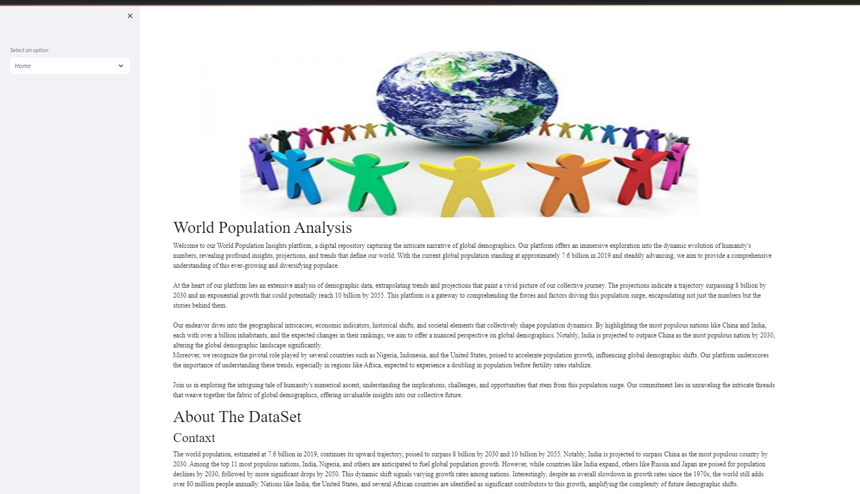

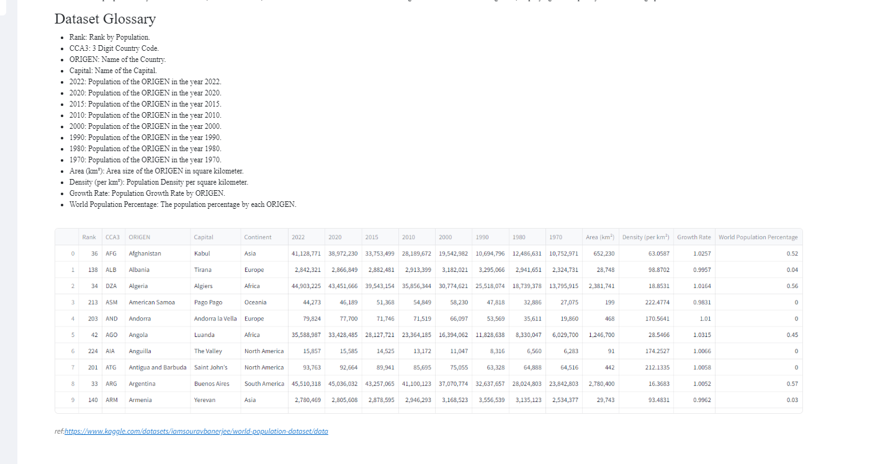

**Prediction page**

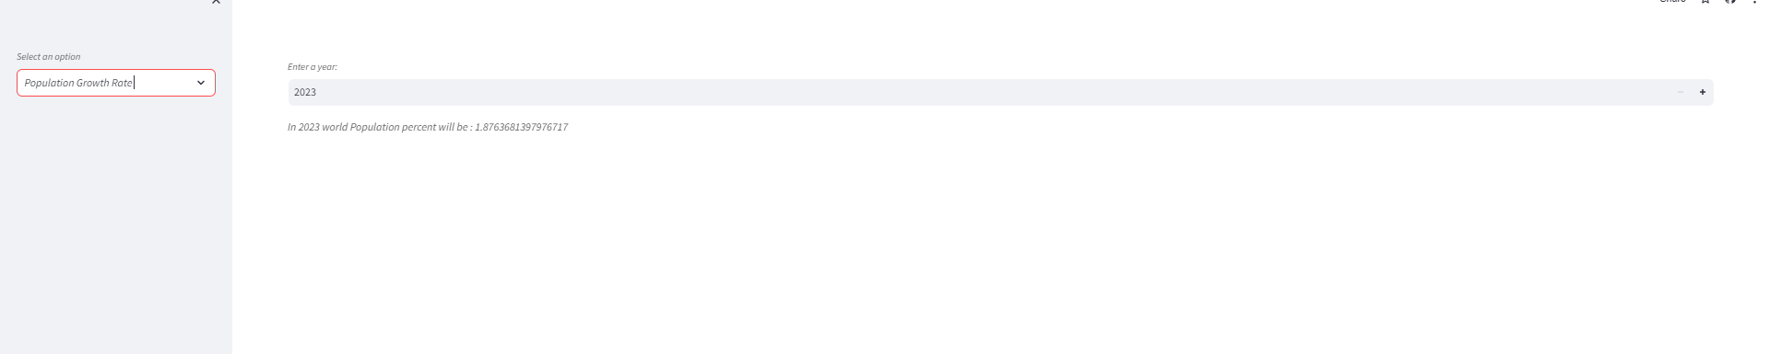

**Visualization page**

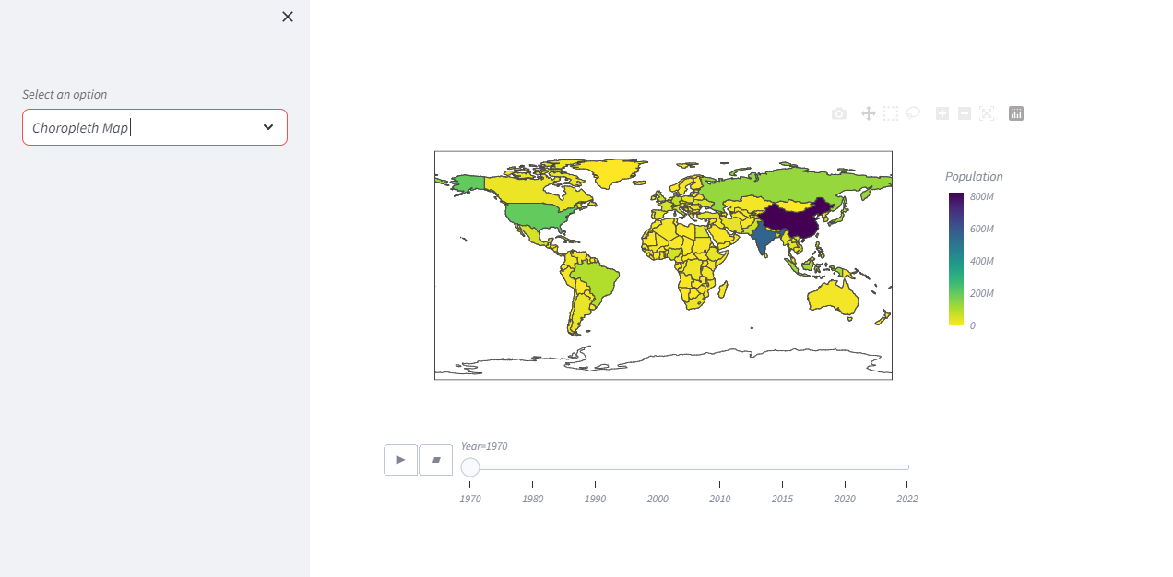

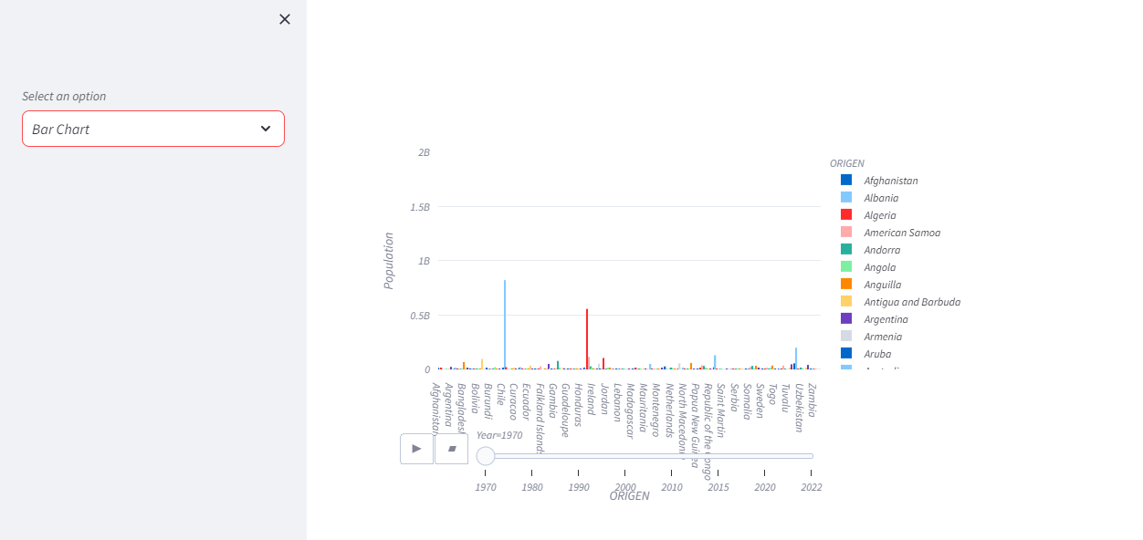

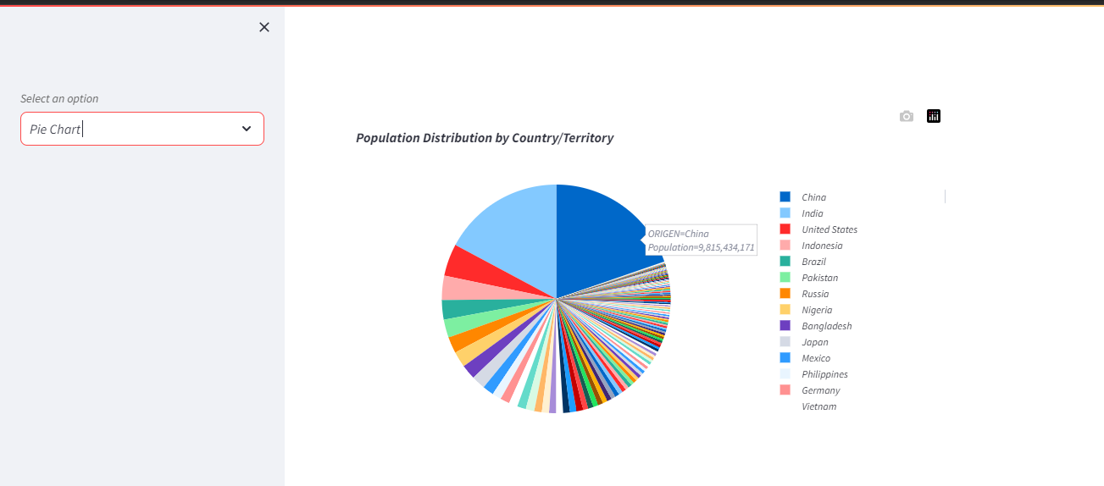

# **References**

[1] <https://www.w3schools.com/python/python_ml_getting_started.asp>

[2] <https://youtu.be/KgCgpCIOkIs?si=c8j6XzY5-vXTBRVf>

[3] https://docs.streamlit.io/

[4] <https://colab.research.google.com/>